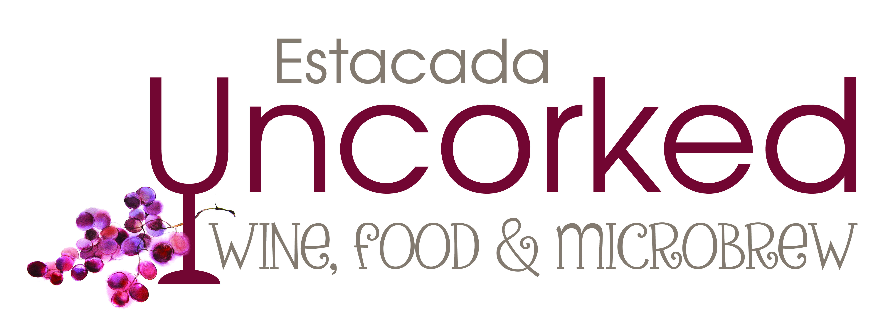
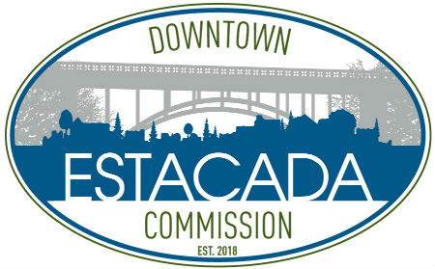

2020 Vendor Handbook

Date and Important Times
Event: Saturday, June 27, 2020 from 3-8pm
Vendor set-up starts at noon and must be complete by 2:30pm.
Vendor take-down will begin at 8pm.

Advertising
Please email a copy of your company logo and photos that help promote your product and image to estacadauncorked@gmail.com. In June, listen for radio advertising on KINK 101.9 and LIVE 95.5 and read about us in The Oregonian’s wine tasting list. In addition to the advertising arranged by Estacada Uncorked, you are encouraged to promote the event as much as you can through social media, websites, print advertising, TV, and radio. Please use the provided Uncorked logo, other images, and rack card pdf in your posts.

Booth Space
As configuration within the big tent was difficult for many vendors, this year each vendor is required to bring his own 10x10 pop-up canopy. We recommend and prefer white, but will accept other colors and custom canopies. We will provide one 6’ folding table and two folding chairs for your booth. You may bring additional tables and chairs, as well as any additional furnishings including linens, signs and pricing info, and serving supplies.

When you arrive, our volunteer crew will help you take your equipment and merchandise to your booth space. Refer to the Vendor Map for details. Vendor parking will again be held in the grass lot off of Jeremy Loveless Avenue, with provided shuttle rides back to the event area.

Restaurant Health Permits
All vendors serving food are required to obtain a special event permit from the Clackamas County Health Department. This permit must be posted in your booth. Contact the Health Department directly at www.clackamas.us/publichealth or call (503) 742-5300.

Insurance Certificates Required
All food and beverage vendors must provide Estacada Uncorked with a Certificate of Insurance listing the City of Estacada as a certificate holder and additional insured for the duration of the event. The certificate shall read: “The City of Estacada, its elected officials, officers, agents, employees, and volunteers are named additional insured solely with respect to their interest in the operations of the named insured for all events to which the City of Estacada requires the insured to add them as an additional insured under a written contract or agreement currently in effect, or becoming effective during the term of the insured’s policy.” Certificates must be received by June 15, 2020.

On Alcohol

All tastes and pours MUST be served in an Estacada Uncorked glass. Violators will incur a fee of $250 per instance.

Tasting Tokens
Paid admission at the entry gate will provide attendees with a commemorative glass, a wine totebag, and three tasting tokens. Vendors will not be reimbursed for tasting tokens, however these tokens open up an opportunity for conversation between you and the patron that should encourage them to purchase their next glass or bottle from you. The price you set for additional tastes and pours is at your discretion and is not subsidized by Estacada Uncorked. Multiple tastings may not be combined into one glass.

OLCC Pour Sizes
Please display a sign that shows your pricing, taking into account the OLCC requirement for pour sizes. The commemorative Uncorked glasses are 15oz. The OLCC limit is 5oz for wine and 13oz for malts and ciders. Tastes are limited to 1.5oz of wine or cider and 3oz of malt liquor, regardless of whether compensation is monetary or by token.

Sales by the Bottle
While sales of wine are allowed by the bottle and the case, these sales are for off-site consumption only. Under no circumstance should any vendor open a bottle of wine for a patron. Violators will incur a fee of $250 per instance. Sales for on-site consumption are by the taste or by the glass only.

Age Limit and ID Checks
All ages are welcome at this event. Uncorked security personnel will conduct ID checks and provide wristbands allowing the consumption of alcohol. It is incumbent on every vendor to assure that no alcohol is served to any person who is not wearing a wristband. A wristband issued by the gate volunteers and alcohol monitors is the gold standard for to whom you may serve alcohol. Vendors are required to double-check the ID of any patron who appears to be 26 or younger. A wristband is not proof of age, per the OLCC. Signs will be posted at the entrance to the event instructing attendees to keep ID handy for spot checks.

Liquor Liability and OLCC Permits
All alcohol vendors must have liquor liability insurance listed on their certificate of insurance and must provide Estacada Uncorked with a special event permit (SEW or SEB, for example) application for the OLCC with a check made payable to the OLCC for the appropriate fee. DO NOT SEND APPLICATIONS AND PAYMENTS DIRECTLY TO THE OLCC. Mail your event permit application to:
Estacada Uncorked
PO Box 958
Estacada, OR 97023.

All checks and applications will be received by June 1, 2020. The insurance certificate should be received by June 15, 2020.

Additional Vendor Perk
Each paid and registered vendor shall receive two commemorative glasses, two wristbands, and four tokens as a thank you from the Estacada Uncorked Committee.

